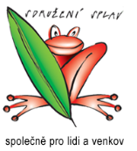

Organic and pesticide free agriculture

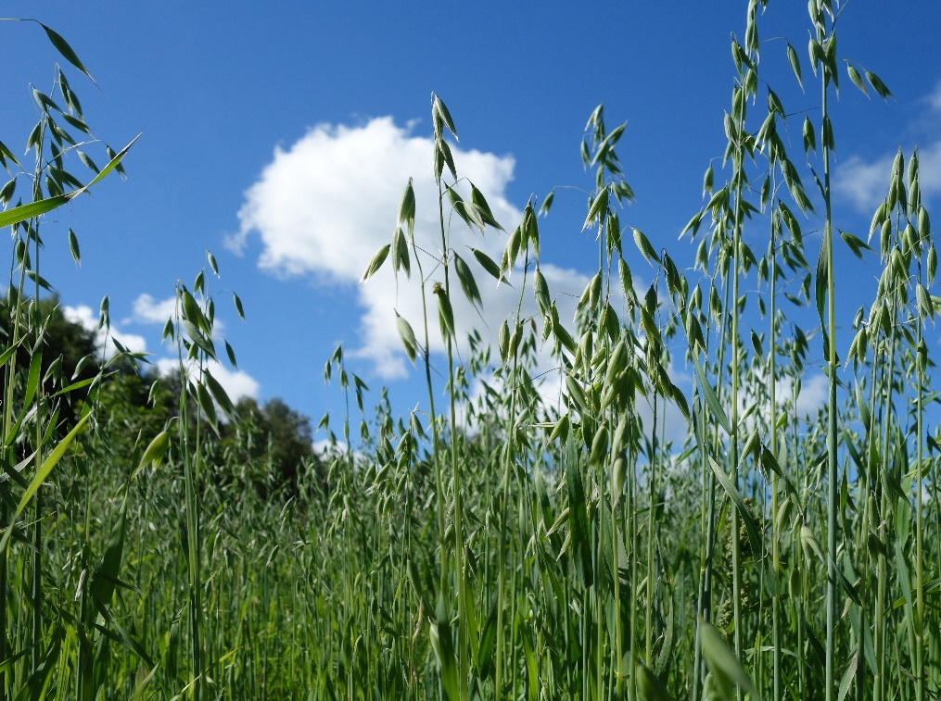

Organic Agriculture (otherwise: biological, ecologic or biodynamic) means a management system with sustainable crop and livestock production within the farm. It is based on biologically and technologically unprocessed means.
In organic farming, the use of chemical and synthetic pesticides is abandoned. It is possible to use only a few preparations based on plant or mineral. The aim of plant protection in organic farming is first of all to eliminate the cause of harmful organisms. So preventive measures are the most important for organic farming.
What are pesticides?
Pesticides are chemical compounds used in the protection of crop plants in order to reduce or eliminate pests, diseases, weeds etc. By definition, these substances should be characterized by:
- high toxicity in relation to pests
- low toxicity in relation to other organisms (including water, useful insects and human being)
- adequate durability
- high susceptibility to degradation.
In practice it turned out that to obtain a substance with the above-mentioned characteristics is generally not possible. The vast majority of pesticides available on the market have a proven harmful effect on living organisms, including human beings.

Environmental effects of pesticide use.
Pesticides are easily spread in the environment by air and water, often at a very long distance. Due to their persistence in soil, toxicity and high biological activity create a threat to the environment. Changes that occur in the soil are long-lasting and little noticeable. In water, they affect negatively on flora and water fauna.

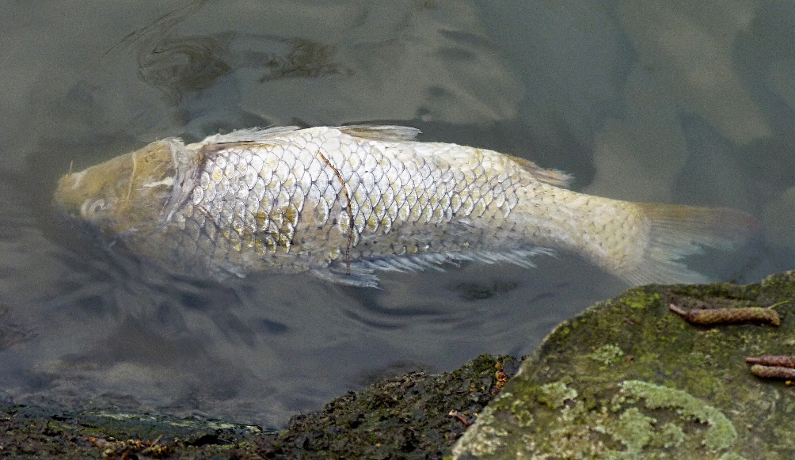
By Jamain (Own work) [GFDL (http://www.gnu.org/copyleft/fdl.html) or CC BY-SA 3.0 (https://creativecommons.org/licenses/by-sa/3.0)], via Wikimedia Commons

The most serious effects of pesticides should be the phenomenon of immunization of pests to the used preparations. They often work more strongly on parasitic and predatory insects than on herbivorous insects. The pest population, which is not inhibited by natural enemies, revives quickly and becomes even more aggressive. In addition, pesticides disrupt the natural food chains, thus eliminating the natural enemies of crop pests. An example illustrating this situation is for example the invasion of shell-free snails in recent years.

Pesticides also kill bees, which account for 90% of all pollinating insects. Chemical plant protection products limit biodiversity.
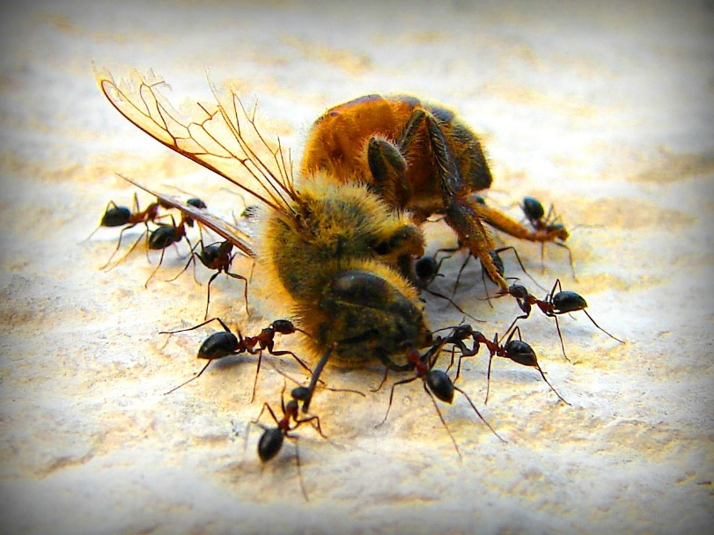
By Hamed Saber from Tehran, Iran (Delicious Dead Bee and Hungry Ants) [CC BY 2.0 (http://creativecommons.org/licenses/by/2.0)], via Wikimedia Commons
Health effects
Pesticides pose a direct threat to health, and sometimes to human life, mainly for people associated with their production or use.
Pesticides can cause:
- Impairment of the central nervous system
- skin diseases
- stomach diseases and poisoning
- hormonal changes
- weakness, dizziness, foot paralysis
- respiratory system impairment
- changes in the liver and kidneys
in addition, they have mutagenic and carcinogenic effects.

Can agricultural cultivation be carried out without the use of pesticides?
Yes you can. In organic farming, the use of chemical and synthetic pesticides is abandoned. The method of plant protection in organic farming is first and foremost the removal of the cause of harmful organisms. Therefore, indirect methods of plant protection and preventive actions are of utmost importance for organic farming. Plant protection preparations (produced on the basis of plant or mineral) are used only when harmful organisms multiply beyond acceptable limits. The basis in organic farming is to maintain a balanced ratio of harmful organisms and their antagonists.
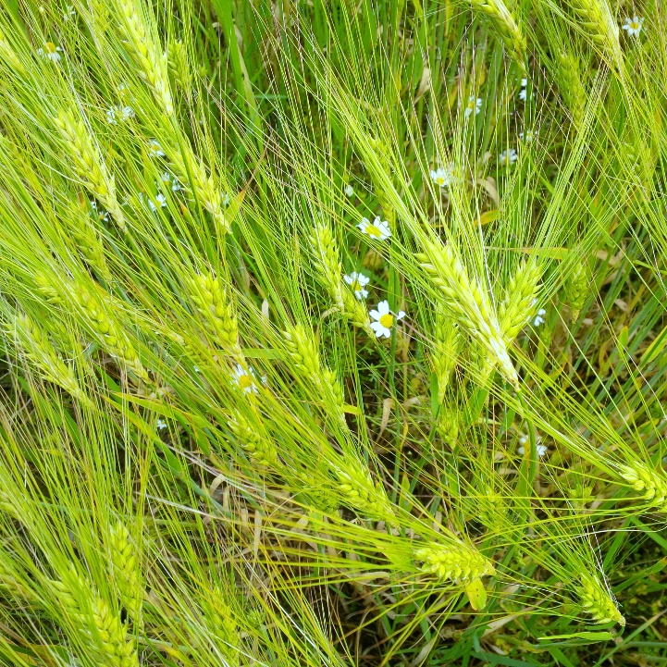

How can you manage without pesticides?
In organic farming, plants can be protected indirectly, that is, preventing and shaping resistance through the use of the following methods:

Care for soil fertility and biodiversity – One of the most important properties of soil is its natural ability to reduce the occurrence of diseases. Plants cultivated on biologically active soil obtain natural resistance to harmful organisms. Most living organisms have their natural enemies in nature.

If harmful organisms spread in the environment, there are no beneficial organisms or they are weakened, conditions for massive multiplication of pests and diseases arise. Therefore, in addition to the care of healthy and living soil, it is also very important to preserve biodiversity in agroecosystems, which is necessary for self-cope of these systems with diseases and pests (buffer significance of diversity).
Plants nutrition – plants in an environment with balanced nutrition are more resistant to pathogens. Balanced nitrogen fertilization is important. Thanks to this, plants with limited access to nitrogen have a more compact and resistant tissue. For comparison, plants that have been nitrogen over fertilized are much more susceptible to certain fungal diseases and pests. In ecological farms, balanced fertilization is ensured mainly through compost from manure of livestock on the farm and green manure. The main principle of organic farming (important in maintaining good plant health) is: "We do not fertilize plants, but fertilize the soil, which then nourishes the plants". Regular organic soil fertilization has a major impact on plant protection, as it contributes to:
- increase in soil biological activity
- stabilizing the soil structure
- balanced and varied plant nutrition
- enriching the soil with substances that strengthen plant resistance.
Cultivation methods – an appropriate selection of plant cultivation stands, including crop rotation, proper selection of varieties and seed material, compliance with the date of sowing and planting appropriate to the plant variety, preservation of the correct vegetation structure, adequate sowing and planting depth, plant nutrition and compliance with phytosanitary rules. The selection of proper crop rotation is of key importance for healthy crops.

Crop rotation – as part of treatments to control pests at rest and activity, it stands out: exclusion of plants from cultivation, which will contribute to the interruption of the pest development cycle; disorder rest of pathogens in order to activate it at the wrong time for them; cultivation of forecrops and catch crops (with their roots stimulate pathogens in their resting stages to development, while there is no plant growing (which feeding them), thanks to that they do not reproduce. The crop rotation is the basic method of cultivation in organic agriculture.
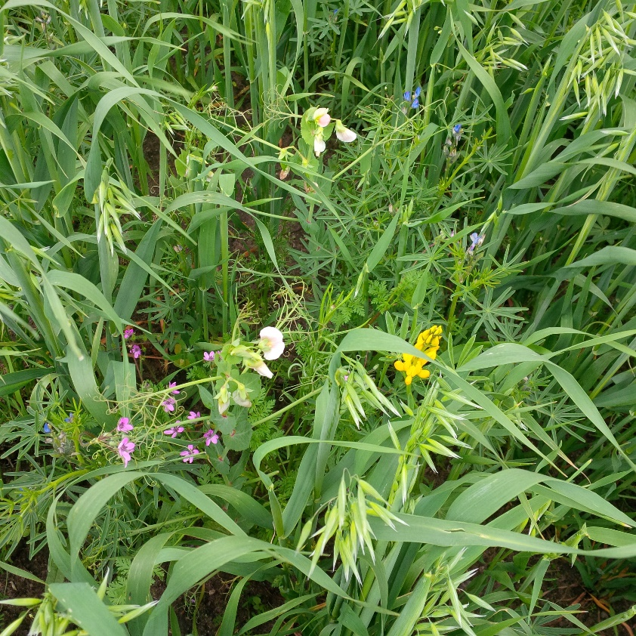
Selection of the right cultivation position – the selection of suitable plant species for cultivation should be adapted to the type of soil and climate. Plants that do not have optimal conditions for growth and development show greater sensitivity to harmful organisms.
The right choice of plant variety – The plant variety should be selected based on recommendations to specific growing regions. Depending on the variety, the plants are also characterized by a certain degree of resistance to diseases and pests. The correct choice of the variety is an important preventive measure against diseases of cereals and potatoes.
Seed and seed potatoes – It should be remembered that healthy seed and seed have a significant impact on the later state of health of the plant being cultivated.
Applying green manure, and catch crop - increase the biological activity of soil, support natural antagonists of diseases and pests.
Protection and targeted cultivation of the soil – properly cultivated soil improves biological soil activity and creates good conditions for young plants. If there is not enough air and water in the soil or if the crop plants are suppressed by weeds, grow slower and are more susceptible to pests. It is recommended to take action against plants that transmit diseases and pests, for example removing crops grown from seeds that have fallen out during harvest; or potato plants that have sprouted from not collected tubers. In addition, it is necessary to introduce into the soil (cover) the plant residues infested by pests / pathogens, which will which hamper their development.

In the case where indirect methods do not work, biological plant protection products can be used. The Regulation of European Commision (WE) nr 889/2008 in appendix II „Pesticides and plant protection products” base on art. 5 point 1. contains a list of authorized substances and methods of plant protection in organic farming. Among them there are means of protection: biological (predatory insects, parasitic, mites, nematodes, microbiological preparations), mechanical (optical traps, adhesive tapes, non-woven fabrics, meshes and repellents), chemical, mineral and organic (copper preparations, rock powders, paraffin oil, potassium salts, lecithin etc.), as well as plant extracts and oils and pheromone traps. This regulation is obligatory to organic food producers wishing to export their products to the EU market.

Good neighborhood of plants favors their health – this is an important relationship especially when growing vegetables. Plants and vegetables should be so planted that they are not limited to each other. It is unacceptable to compete for water, sun or minerals between plants, because then it is known that plants sooner or later will be wasted or not as attractive as they should. Therefore, planting should be planned in such a way that each plant has enough space for itself, both in the above-ground and underground parts. It is worth choosing plants so that they help each other in growth, eg they increase resistance to various diseases or repel potential pests. Then we can say that there is good plant neighborhood in the garden.
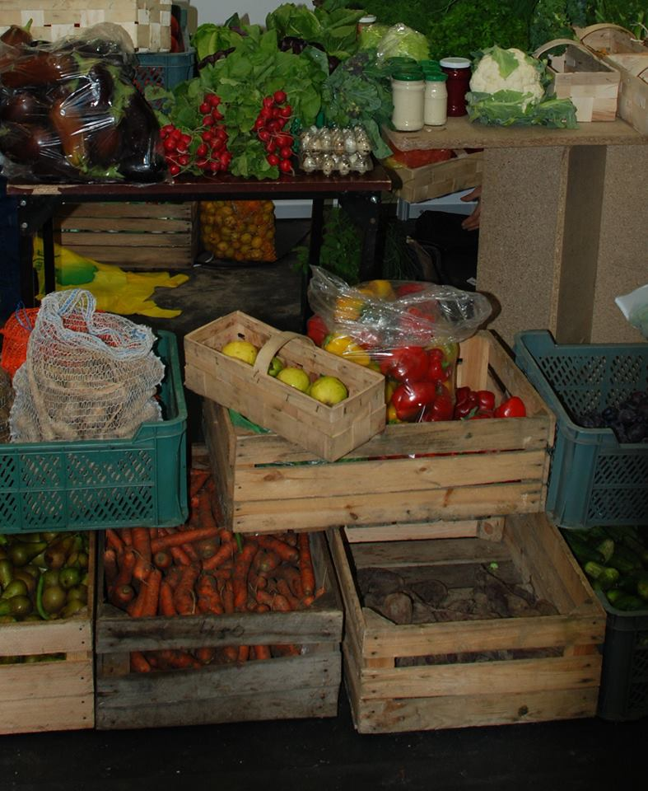
Paying attention to appropriately good neighborhood of plants and vegetables is especially important in ecological gardens, where no chemical means of fighting diseases and pests of plants are used. Then the selection of a good neighborhood of plants and vegetables is often the most important form of combating pathogens.

The table on the right shows examples of good neighborhood for the most commonly grown vegetables.
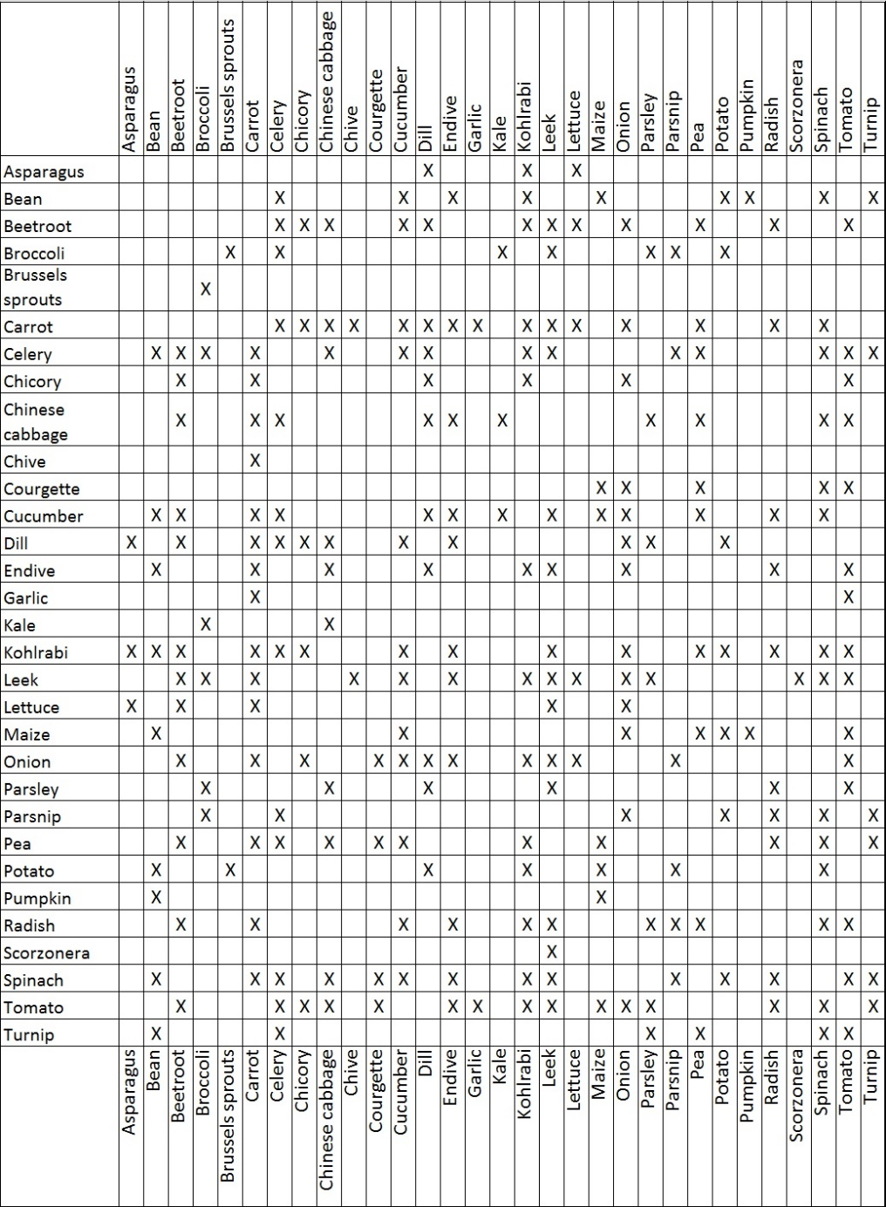

Community models of organic and pesticide free agriculture

Community supported agriculture

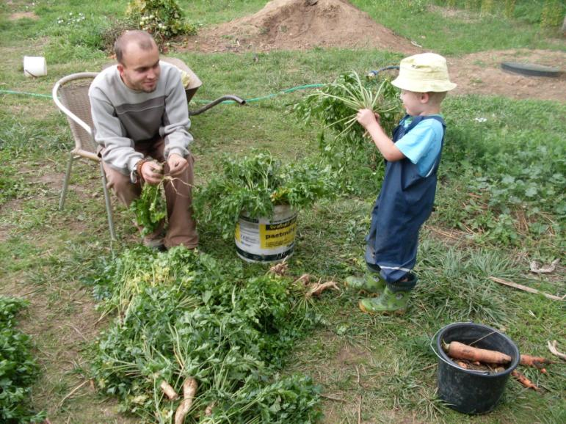
Community-supported agriculture (CSA) is an alternative socioeconomic food production and distribution system that directly connects farmers and consumers. Typically, this model is created by community of consumers and farmer/farmers who provide their products (fruit, vegetables, dairy products, meat) directly, without inter-elements such as shops, marketplaces, etc. CSAs generally focus on the production of high quality foods for a local people, often using organic or biodynamic farming methods, and a shared risk membership–marketing structure.

The core idea of CSA is developing a cohesive consumer group that is willing to fund a whole season’s budget in order to get quality foods. People buy "shares" of a farm's harvest in advance and then receive a portion of the crops as they're harvested.
Farmers get important early-season capital and have a guaranteed market for their produce. Within CSA model growers and consumers support each other and share the risks, as well as the benefits. Consumers are not only passive recipients, but active members of the food system. This kind of farming operates with a much greater degree of involvement than usual, resulting in a stronger consumer-producer relationship.
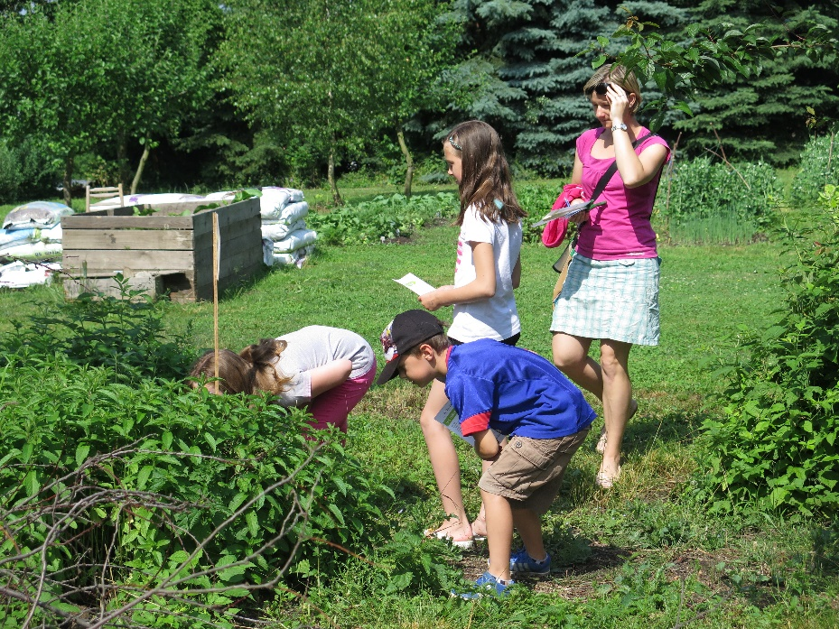
The system has many variations on how the farm budget is supported by the consumers and how the producers then deliver the foods. Most CSAs require an annual buy-in and provide weekly deliveries or pick-ups, but some well-established programs can offer monthly or even weekly memberships. Some CSAs offer more than fruits and vegetables, such as eggs, honey, flowers, and even poultry and other meats. Some farms keep distributing even during the low season months offering members jams, pickles, or other preserves they've made during the peak of harvest.
Prices are usually comparable to conventional food, because it is reduced by the part of the production process between the farmer and the end customer (transport, supermarket, warehouse etc.).
CSAs also usually offer farm visits, u-pick days, and other special events for their members.
Why Start a CSA? Why Join a CSA?
Starting a CSA has advantages for both the farmer and consumer. For you, the small farmer, you can spend time marketing your food during the off-season, before your seasonal workflow gets intense. You also get paid early in the season, before you have to spend a lot on seeds and labour, so your cash flow is better. And, CSAs allow you to connect deeply with your community, really letting you get to know the people who want your food. You can adjust your offerings to their desires and needs and create a more successful, responsive business.
In order to effectively market your CSA, you also need to understand why your potential customers would want to pay up front for an entire season's worth of produce. For CSA shareholders, they are looking for the freshest, most local food possible. Many care about whether chemicals are used on their produce, so they may be looking for chemical-free food. They enjoy a good price on vegetables because they buy the share up front. And getting a large box of veggies every week gives them an incentive to eat healthier. Most CSA shareholders value the relationship with the farmer that they get by joining the CSA, as well. They may be interested in the workings of the farm or enjoy getting a discount for volunteering their labour.
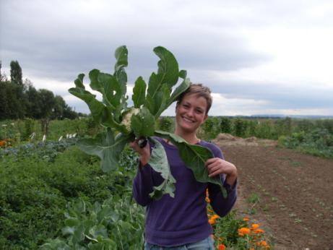

This approach eliminates marketing risks as well as costs of time and human resources, allowing farmers to focus on soil quality, crops, livestock – and customer service.
Example: KomPot
KomPot (Community Food) is an association established in 2012. Community of people decided to start growing vegetables and small fruit on the land in Středokluky, Czech Republic. The association has two employees – gardeners, but all members are involved in the management and development of the growing place. Currently there are grown more than 40 kinds of fruit and vegies and about 37 families are supplied with seasonal production.
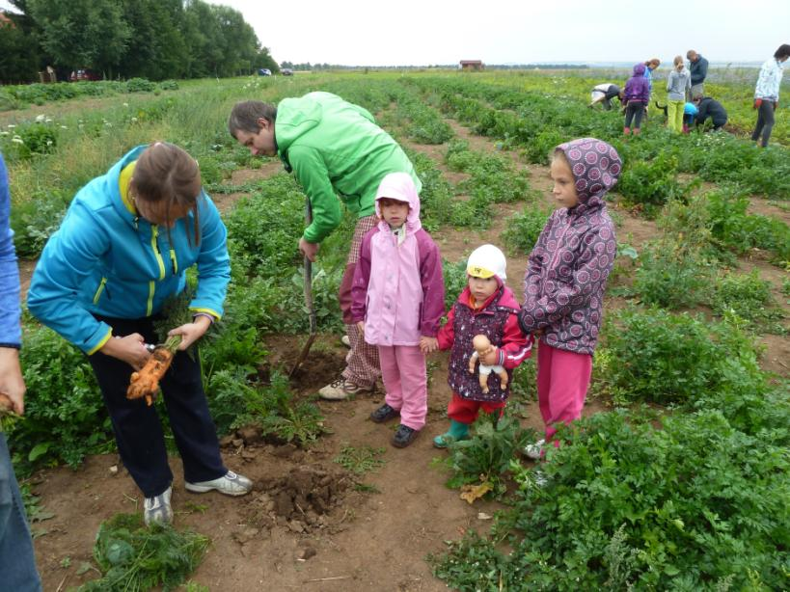
The garden operates within the principle of community-supported agriculture, where everyone shares both benefits and risks of growing and more or less contributes to the production and economy. KomPot is one of the first examples of CSA in Czech Republic where consumers themselves grow their own vegetables.

The plot is divided into production and social part. The social part is managed by the members themselves. They organize social events such as pumpkin day, thanksgiving or various educational activities for children or for the public. The area of the production part is about half a hectare and in the season it produces up to 180 kg of vegetable/fruit per member, which is just enough for most of them.
There are two paid gardens and seasonal workers managing the production part. But KomPot is community-based, se there are volunteers from the members helping on weekly bases in high season and when the weather allows even off-season. The minimum amount of work is 4 full days a year. But it is only a direction, no one checks how much each person works – it is on the decision and conscience of each member. Work on the field can be replaced by any other help such as administration or bookkeeping.
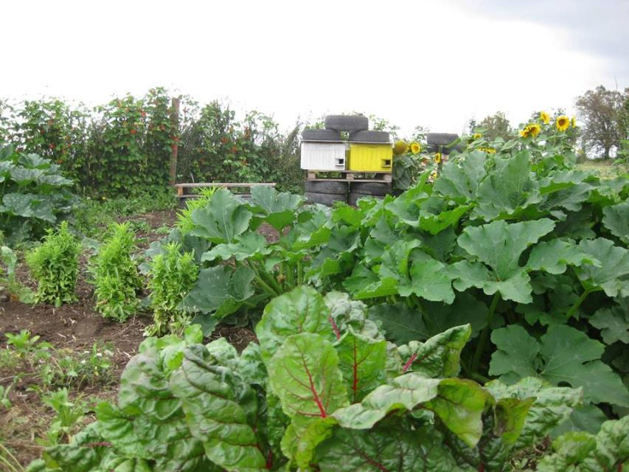
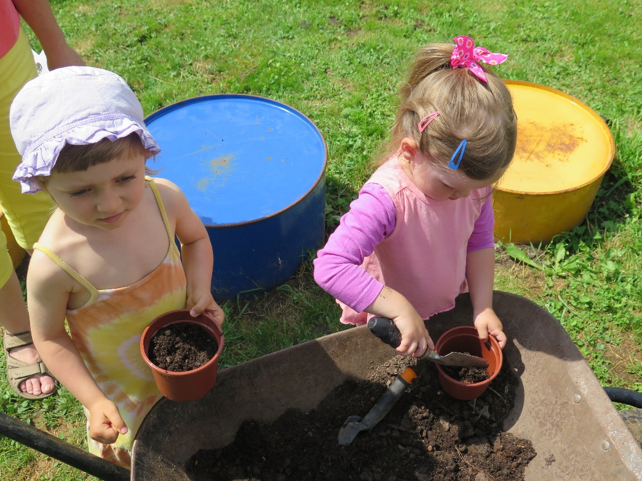
Majority of members have joined KomPot for the fresh vegetables from local sources. Some people wanted to learn gardening or just to be in contact with nature. There are also several families with children among the members. For many parents it is very important that their children can see where the food comes from and how big is its value – not just financial, but also how much time and energy it costs to grow a vegetable box. KomPot gives an opportunity to change your lifestyle, get new approach, meet new people and learn new things.
At the same time, KomPot develops educational, awareness-raising and leisure activities related to horticulture, organic farming, soil care and sustainable development for both children and adults.
Social farming
Social farming (sometimes also called Care farming) is related to so-called ´green care´, which is an umbrella concept for various activities based on the mutual interaction of man and nature for the purpose of human well-being. There are a number of ways how the green care is implemented (e. g. horticulture therapy, animal assisted interventions, Eco therapy), but most complexly through social agriculture/social farms.
Social farming utilizes farming and agriculture as a therapeutic tool to provide health, social, or educational care services for one or a range of vulnerable groups of people, which can include people suffering with mental health problems, physical disabilities, learning disabilities, and drug/alcohol addiction as well as adults and young people on probation. It creates conditions within farm or through farming activities that allow vulnerable groups of people to be included in normal society while at the same time improving their physical and mental state. In social farming the farm remains a working farm at its core but invites people to participate in the day to day activities of the farm. Therefore the farm is not a specialised treatment farm, but it is a place where people in need of support can benefit from participation in farm activities in a non-clinical environment. It also creates the opportunity to reconnect farmers with their local communities.

Social agriculture is based on the multifunctional concept of agriculture, which means that in addition to growing food for the population (production function), the agricultural sector also has other non-production functions – protection and maintenance of natural resources, development of leisure potential, maintenance of local traditions etc. Last but not least, agriculture helps the regeneration and development of the regions, it makes it possible to evaluate the local rural space, creating new jobs, which represents the social function of agriculture. Social agriculture develops the social function of agriculture by employment of people disadvantaged in the labour market and by social and educational services and rural activities for a wide range of target groups.
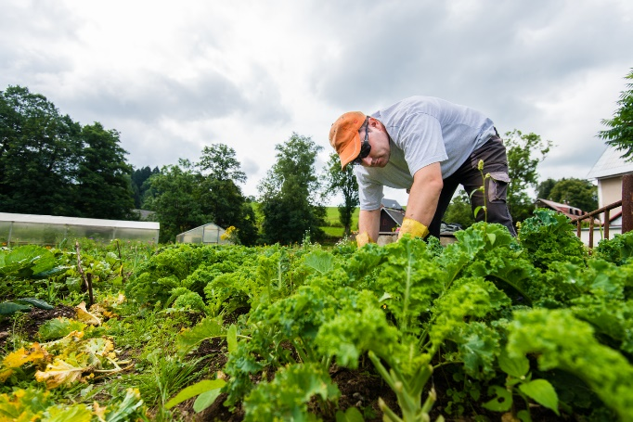
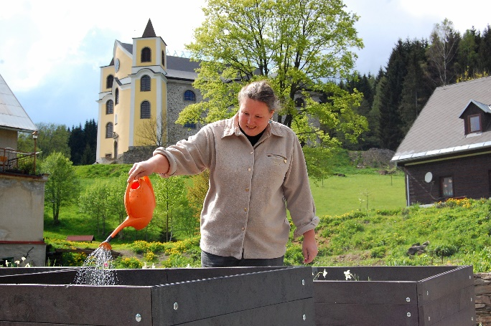

Social agriculture can be seen as an alternative and innovative approach to social work. It is helping people who are in a difficult life situation giving them opportunity to spent time in a farm environment, working with animals and plants and fresh air. The frequent benefit of the farm is its natural and non-judging climate. At the same time, participants/clients engage in meaningful and responsible activities that help them gain a better assessment of themselves, to realize their possibilities and limits, learn new skills, communicate and improve their physical fitness.
The main objectives of social agriculture are:
- promoting the quality of life of individuals,
- social integration in the countryside,
- development of rural communities,
- development of the local economy,
development of non-agricultural components of agriculture.
Example: Sdružení NeratovThe non-profit organisation Association Neratov has been established in 1992 to restore the displaced and disappearing Neratov village and offer home and work opportunity to people with disabilities or somehow socially disadvantaged, who would actively participate in Neratov restoration. People with disabilities can work in agriculture, landscaping, traditional folk crafts and services for other residents of Neratov and the region, as well as for tourists from all over the Czech Republic and abroad. At the moment, there are about 110 employees, 85 of them with disabilities. Some of these clients are also living in Neratov, together about 30 of them. There are also helped children with combined disabilities, 12 in the local special school.

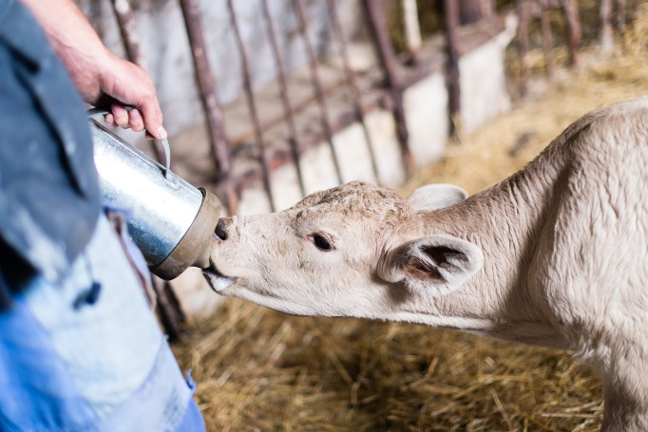
Neratov is situated in the Protected Landscape Area of Eagle Mountain (Orlické hory), so many clients work in horticultural and agricultural. There is social farm and garden centre. Social farm is located in the neighbouring extinct village Vrchní Orlice. People take care of cattle, sheep and pigs kept in the ecological regime and in cooperation with PLA Eagle Mountain management employees preserve mountain meadows. Garden centre is beneficial for the whole community – it provides work to some residents; harvested goods are partially consumed in the local canteen and partially sold at the local store which generates income; products are not certified as organic, but all is grown within the ecological principles. Gardeners also maintain green public spaces (local cemetery and public flowerbeds, mow grasslands and in winter take care of roads and paths) and fruit orchard with local traditional varieties. They also prepare fuel wood and offer their services including grass mowing or technical works to the local inhabitants.
People working in horticulture and agriculture (but also in other positions) are mostly people with special needs – some with mental retardation, others with physical disabilities or having mental illness. The specific activities depends on their condition and abilities – everyone contributes as much as he/she can. Clients work together with assistants who are present at all the times and are ready to advice and help. Garden centre is partially adapted to the needs for the people with physical handicap – raised beds, electric wheelbarrow etc.
The aim of Neartov association is to offer employment to every person with special needs who is interested to work. Therefore, besides the physically demanding activities in agriculture, there are also job opportunities in the services (cooking, sales in the shop), in sheltered workshops (ceramics, basketry, weaving, sewing, etc.) and also in the administration.
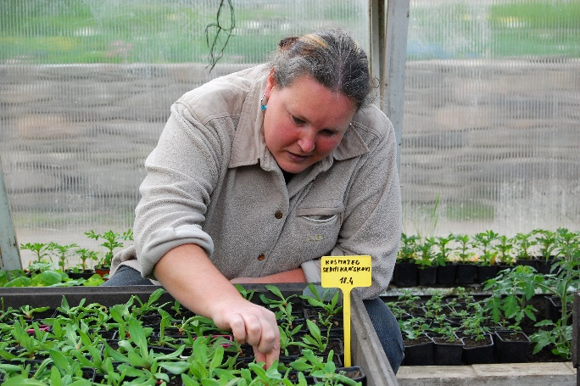
People with disabilities are involved in Neratov's daily lives also beyond their job responsibilities. They help organize cultural and social events, play theatre, and participate in charity projects. Restoration of Neratov is positively influencing the whole region – the association is important employer in the area and it has become a famous tourist destination (about 25-30 thousands visitors per year) – it has a wide range of services for both residents and newcomers, the network of public transport and hiking trails has densified, many old houses and settlements were repaired including famous pilgrim church.
The Neratov Association is based on the transparency of its activities and the quality of its products. Their services and products are certified by the ´Work of the Disabled´ brand, which proves their quality and competitiveness, as well as a good working environment for the people with special needs, the craft products have brand Eagle Mountain – original product´ guaranteeing the use of original local procedures and predominantly regional raw materials.
Camphill biodynamic agriculture
Camphill communities are more or less self-serving villages or farms, which have a strong spiritual and value bond. It is a community concept, where healthy people live and work together in family atmosphere with people with special needs; it can be said, that the Camphill is a special type of housing with a job option.
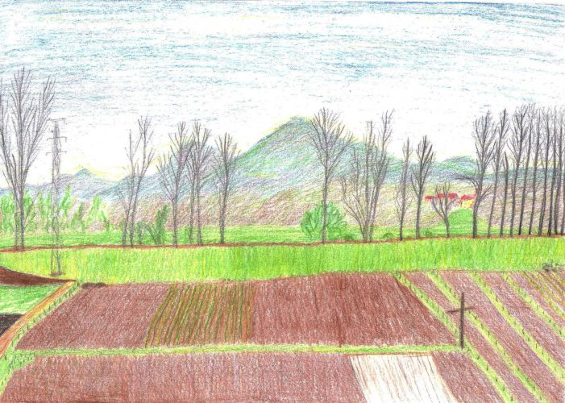
It´s principles were derived from concepts of education and social life formulated by anthroposophist Rudolf Steiner. The philosophy states that ´a perfectly formed spirit and destiny belong to each human being´. The movement was founded in 1939 in Scotland by Karl Köenig. Today there are over 100 communities worldwide, in more than 20 countries, mainly in Europe, but also in North America and Southern Africa.
The Camphill community consists of one or more households. Camphill's household works similarly as a standard family. There are always two workers having the role of mother and father of the family and they lead the household. The role of parents means the overall responsibility for the house and its inhabitants, however it doesn´t mean substituting the biological parents. There are several people with specials in each household and depending on the situation their assistants. There is very strong sense of belonging and common family meal is essential part of the day.
The Camphill community consists of one or more households. Camphill's household works similarly as a standard family. There are always two workers having the role of mother and father of the family and they lead the household. The role of parents means the overall responsibility for the house and its inhabitants, however it doesn´t mean substituting the biological parents. There are several people with specials in each household and depending on the situation their assistants. There is very strong sense of belonging and common family meal is essential part of the day.
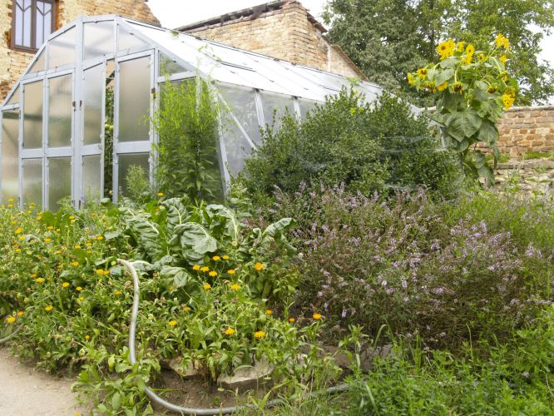

Life in Camphill community is focused on rhythm. And not only on rhythms in daily activities, but also on rhythm of the whole year. The year rhythms are seen mainly in nature and agriculture, but are easily transmitted to the lives of communities in the form of celebrations of various events such as solstice or equinox.

For camphill is significant agricultural approach based on Rudolf Steiner´s ideas – so called biodynamic agriculture. This is one of the oldest alternative farming methods. The basis of this method is anthropocentric philosophy according to which life, soil and the surrounding universe form an integral whole. Similarly to organic agriculture it is built on the environmentally friendly principles to the land and nature in general – no chemicals and excessive harvesting techniques are allowed. In comparison with organic agriculture, the biodynamic one goes even further and is actively trying to help destroyed nature by using natural remedies. These biodynamic preparations work on the similar principle like homeopathic ones. Preparations made from fermented manure, minerals and herbs are used to help restore and harmonize the vital life forces of the farm and to enhance the nutrition, quality and flavour of the food. Biodynamic agriculture also works with planetary influences and rhythmic cosmic processes mainly with the position and phase of the Moon and spiritual forces on soil, plant growth and animal health and uses and astrological sowing and planting calendar. Cyclic processes around the plant affects its rooting, flourishing, fruit formation, etc.; therefore, their knowledge can be used applied in agriculture.
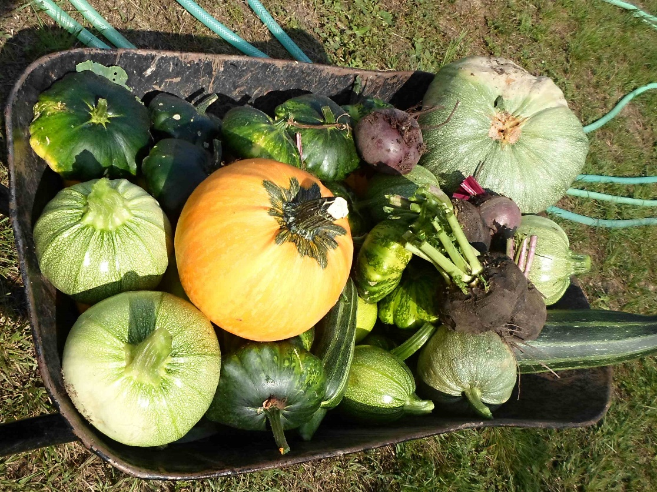
Example: Svobodný statek na soutoku
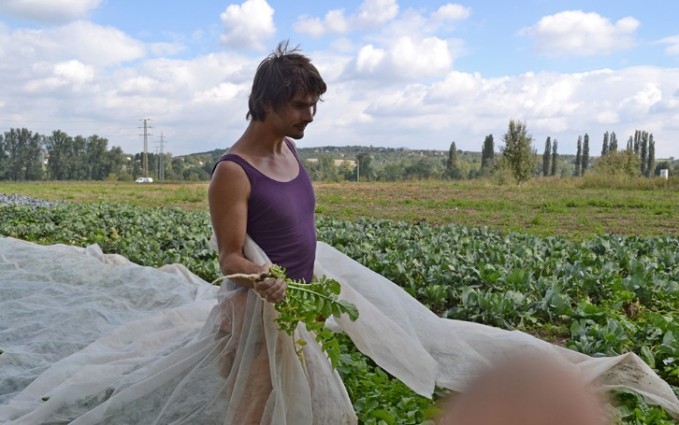
Association ´Svobodny statek na soutoku´ is part of Camphill České Kopisty and has been founded in 2012 with the vision to follow up and professionalize the agriculture activities of the camphill. Biodynamic farming has self-supplying function for the camphill community and in the same time brings financial independency, work opportunities and therapy to the community members.

Camphill České Kopisty runs daily care centre and provides sheltered living. Camphill residents are usually recommended by social services and the length of their stay vary from couple of months to years. There are people with different diagnoses, generally with psychical illness or handicap.
They help several times in week on the fields and contribute according to their possibilities in the farm maintenance. There are also other therapeutic workshops – textile, wood processing and ceramic. The system of farming is based on human labour. Except couple of employees, seasonal workers and camphill members, there are also volunteers, who come for the summer work camps or work on regular base. During two seasons the land use grew up to 6 hectares and camphill became financially independent; until than the agriculture sector was actually a burden. In the moment, there are 11 hectares being cultivated.
There is grown huge variety of mainly vegetables, but also fruit and herbs – pears, apples, melons, strawberries, cabbage, spinach, turnip, earth artichokes, several kinds of pumpkins and squashes, salads, beets, radishes, tomatoes, cucumbers, broccoli and much more. Grown vegetables and fruits are consumed by the community, sold directly on the farm, delivered straight to the consumers by vegetable box scheme (in this case there are ´veggie bags´) or sold to number of shops. Some of the goods are exported to Germany. In the future there will be possible the option to become shareholder in the system of community supported agriculture.
Very important role in the camphill and on the farm has horse keeping. Horses are big help in the agricultural activities – working with soil and hoe, pulling and ploughing; and are used for hippo therapy.

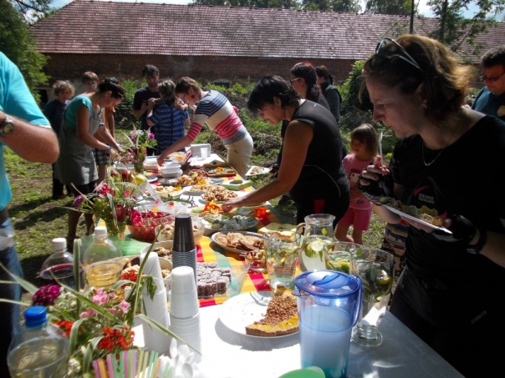
One of the recent projects which has been successfully implemented is candle manufacture. There are number of bee swarms on the farm producing apart of honey also beeswax. Bee as a friend of humankind and a flame as a tool for illuminating darkness. Candles are hand made in sheltered workshop and they are sold through e-shop.
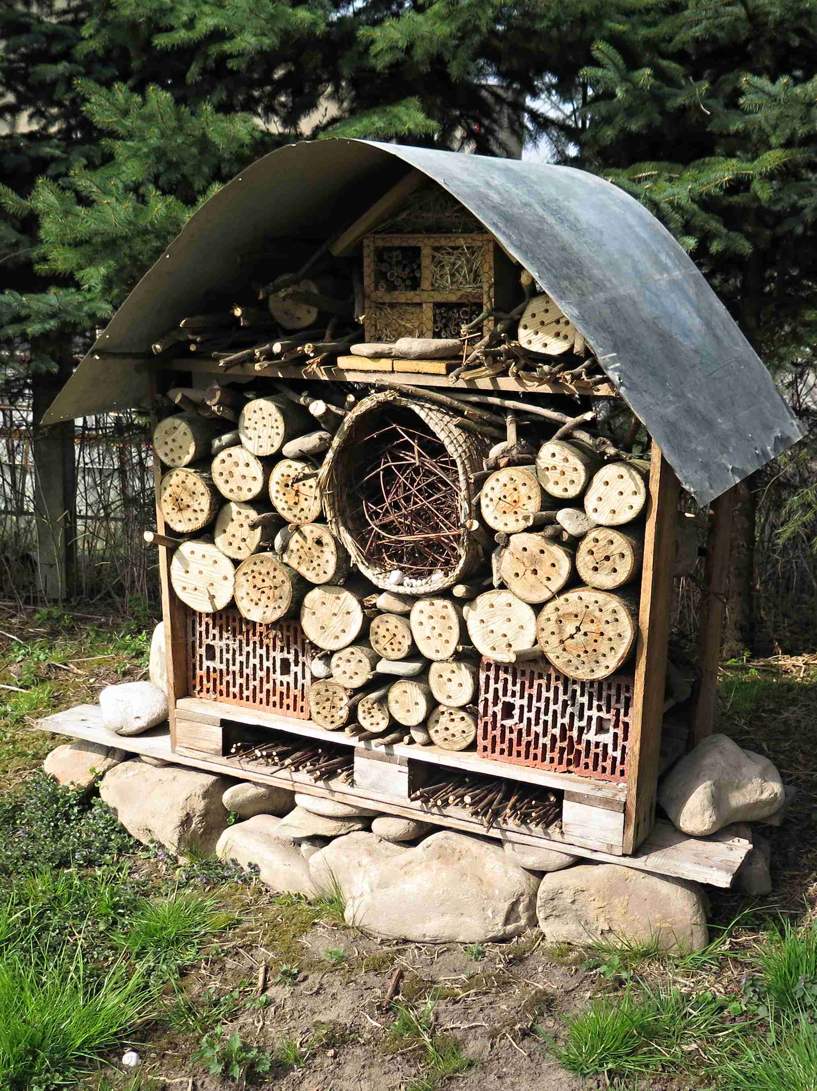
Important part of the farm/camphill life are social and cultural events, which are opening the community to the public. On the regular basis there are organised theatre plays, concerts, exhibitions, harvest festivals etc.
The work and lifestyle of the Camphill České Kopisty is based on believe that life with the rhythm of the year, as it is shown in agriculture, has beneficial effects on the human soul.
Community gardening
Community gardens are getting more and more popular and there is growing demand among various groups of people, who are in nowadays hectic life speed interested in outdoor spaces with community spirit. Phenomenon of community gardens also goes hand in hand with very current topics such as sustainable life style, growing own food, recycling or horticulture therapy.
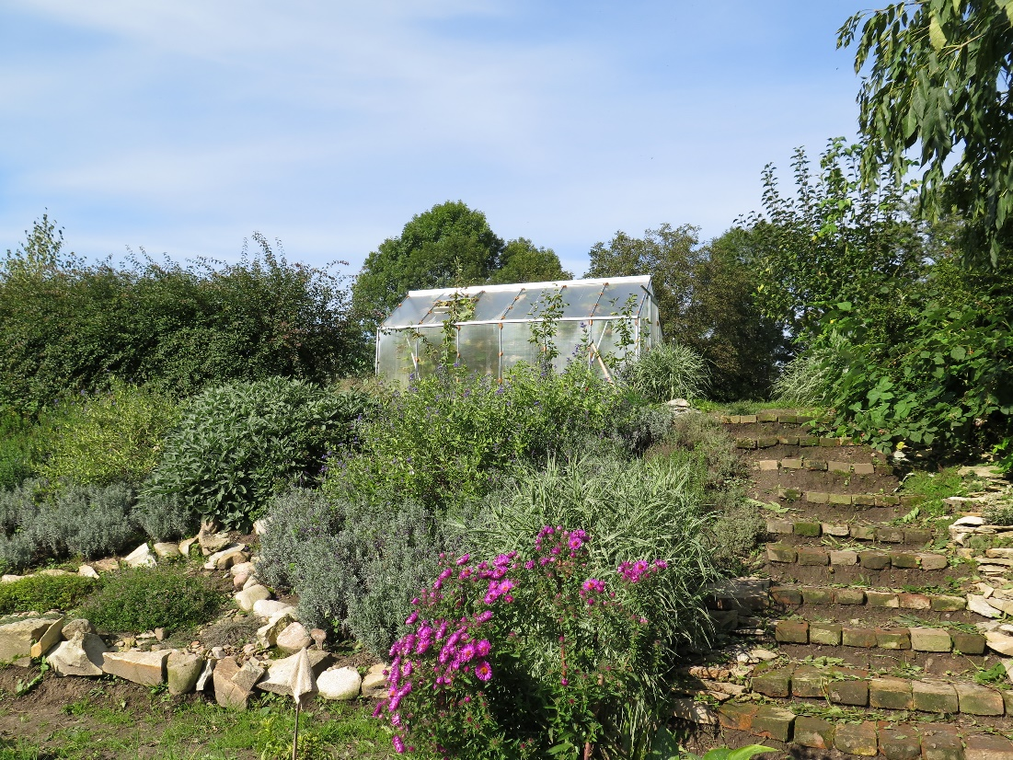

Community gardens have been a traditional in Europe and the UK since the early nineteenth century, when allotments were set aside for the urban working class. Allotments provided a breathing space in the crowded industrial cities and their produce supplemented the food for families. Economic recession of the 1930s, followed by Second World War, brought an interest in community gardening as a means of food production. Despite a decline in the community garden movement after the Second World War, community gardening persisted until the present day and the demand for garden plots is increasing.
The UK, Western Europe and the USA now have well developed and cohesive city farm and community garden movements such as National Federation of City Farms in the UK, Australian City Farms and Community Gardens Network in Australia. City farms and community gardens today range in size and complexity from small, low-cost neighbourhood enterprises to larger establishments.
Community gardens are green spaces in the cities or villages on public or private land created and maintained by people joint by neighbourhood or common goal. People collectively design the garden, choose plants and decide where to grow them, execute the garden, take care of it and share the rewards of gardening activities. Everyone can get involved according to his/her interest, abilities and mood. Besides gardening and harvesting the crop, people benefit from using the garden freely and spending time in healthy outdoor environment. The whole process of learning, designing, establishing, and taking care of a community garden is highly therapeutic for everyone involved, and everyone can find place and his/her role in it. Community philosophy goes hand in hand with the healing process – doing something together, doing something for yourself and something for others.
Community gardens boast a long list of benefits from improving access to fresh food to building stronger neighbourhoods. The gardeners´ harvests also help reduce grocery bills. Being active in a community garden increases physical activity and overall health. Gardening reduces stress, muscle tension, and blood pressure. In addition, a community garden can transform a group of separated individuals into a community. The most important is that gardening improves the way people feel. People and plants grow well together. Plants thrive when people care for them, and in return plants provide amazing therapeutic benefits.
Community gardens can have a significant positive impact on local economics and food security. They also make fresh locally grown produce available to more people. Some community gardeners sell their garden produce at local farmers markets as a way to supplement their income. Others simply reduce their food costs by growing their own fruits and vegetables. Community gardens can be great resource for supplying fresh locally grown produce to local food banks, shelters, pantries etc.

Carefully planned community gardens can help meet all sorts of conservation and preservation goals. In urban areas green spaces reduce city heat. Community gardens can collect rainwater for use in the garden and reduce storm water runoff by absorbing rainwater. The rainwater soaks into the ground and filters slowly through vegetation before entering the groundwater system. Community gardens also introduce a diverse selection of plant into the environment, helping to support native wildlife such as birds, bees, and butterflies.
Community gardens enrich communities by offering an opportunity for community members to volunteer and give back to the community in a variety of ways. As more people retire and some find themselves looking for a meaningful purpose in their daily routine, community gardens offer a beautiful way to fill a day and do meaningful work. Community gardens also provide venues for teaching youth and adults to be more self-sufficient.
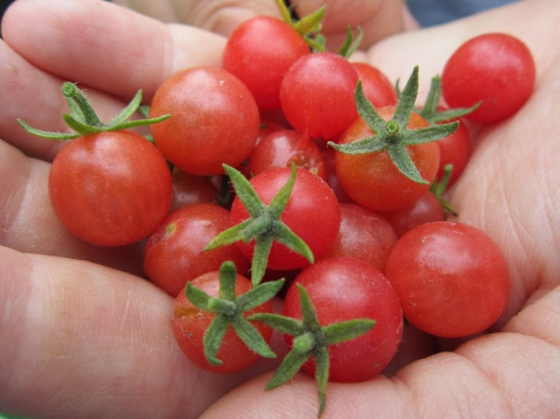

Community gardens are highly diverse. Some target a special population – homeless people, unemployed people, immigrants, people with special needs etc. Other provide horticulture therapy to those with physical or mental challenges or offer soothing sanctuary for patients. Modern community gardens come in an endless variety of sizes, shapes, and purposes, from tiny parks to expansive urban farms. In spite of their differences, all have something essential in common. Whether it is a charity project to grow food, the market garden to engage urban youth in an entrepreneurial adventure, or traditional allotment garden where families grow vegetables for themselves, a community garden´s success and longevity depends directly on the gardeners and how actively they support their garden and how the garden is integrated into the community. Sustainable gardens require more than just growing plants and food; they require people growing together.

Example: Community Garden U SPLAVu
Community garden U SPLAVu has been established within a European Social Fund project in 2013/14. The main idea was to introduce horticulture therapy as a method of help to unemployed people and to offer the social contacts and work opportunities in community market gardens. The project had four phases – 1. Motivation of participants; 2. Community garden establishment + horticulture therapy + education + foreign practice; 3. Retraining courses; 4. Employment in the garden – maintenance, event organising, processing products + final conference. Initial investments has been done with the funding from European Social Fund. It included the establishment of the garden itself, purchase of tools and machinery, international practice, training of the target groups and maintenance for two years (2013, 2014). The total budget was 240.000 Euros. In the moment Sdruzeni SPLAV covers the basic expenses (seeds, petrol etc.) from their own resources and the maintenance with the help of Employment office, which provides few full time workers. In 2018 starts new project in the garden called ´Work together, together with SPLAV´ focused on helping people disadvantaged on labour market and networking all regional institutions and associations with similar portfolio.

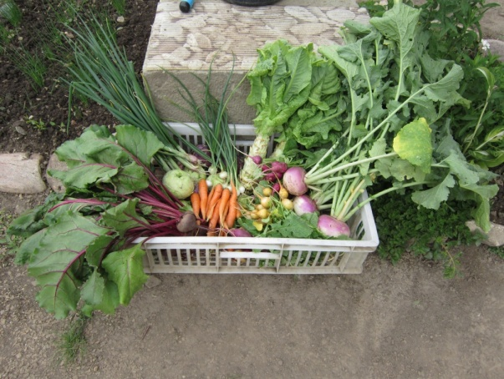
The project was tailored for unemployed people over 50 and unemployed people after parental leave and/or with small children. These target groups are disadvantaged on labour market and often unemployed for long time. They also have to deal with psychological aspects of their life situation – losing a job, children leaving their homes, returning to work after parental leave, taking care of small children etc. These target groups were participating the project. However the community garden as such has been since always opened to anyone who would be contributing and happy to get engaged – from local community to schools and senior clubs. Now there is wide range of people benefiting from the community garden – local schools and kindergartens, people with special need, foreigners from refugee camp, local public.
In general it is very difficult to attract people to community gardens in Czech Republic and especially in rural environment; people have their own gardens and are still quite sceptic to the ´let´s do it together´ topic. Sdruzeni SPLAV tries to reach out the people via Employment office, centres for people with special needs, hobby clubs and social media. Very beneficial is also the presence of nearby chateau and regular farmers markets every month.
The project had very strong both therapeutic and social benefits for its participants. On the first place participants were offered regular sessions with coaches and psychologist, who helped them to start to be positive and active again. On the second place there was the whole common work on the garden from its planning to the planting and maintenance. This has been the truth horticulture therapy – people were positive about their work, they created strong bonds among each other seeing they all have similar problems, they had common goal and future ahead, they were able to see the outcomes of their work on daily basis. And much more. On the third place there were two very inspiring international partners – Juankoski Heritage Society (Finland) running therapeutic community garden and Riverside Market Garden Association (Wales) having community supported agriculture and community garden. Partners were coming over to help out with all phases of the project and 12 participants had chance to get very beneficial practice in their gardens in Finland and Wales.
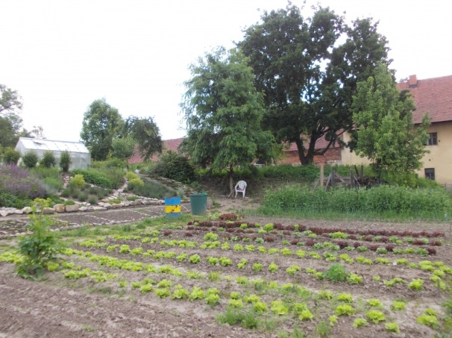

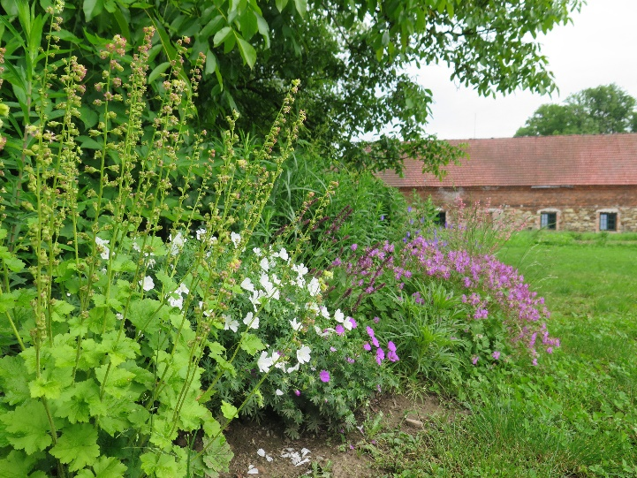
To be able to see that people from far away have same worries and troubles was extremely therapeutic so as simply change of environment. On the forth place participants could attend retraining courses (gardener, general agriculturist, dietologist), which gave them back their confidence and made them more competitive in labour market. On the fifth place there were/are therapeutic and social benefits for other target groups – there are regular days with people with special needs, schools and kindergartens and regular social and educational events for public. Continuously the garden is being developed into an open space where people are meeting in regular events, which are either just for them or opened for public, where they work together or alone, whatever works. Most importantly they are getting closer to the nature and closer to each other.
Most of the people involved in either way in the project and garden are people with interest in healthy sustainable lifestyle. They are from near places, but many are from larger settlements more far away having weekend houses around. It is very difficult to get involved really local people on regular basis. The project helped most the participants to get back their interest in life, to find out they are worth and they can do something valuable. The fear is often reason why unemployed people cannot find job again. The project helped people to get rid of their fears and to stand on their feet again. To some of them it offered payed work for one year, to some it made a carrier change, to some of them new hobby. And everyone got a huge portion of knowledge and experience. About 80% of the participants are working in the moment.
It was one of the first projects of its kind in Czech Republic. It got very positive publicity and the final international conference was very successful. It introduced the terms as horticulture therapy, community gardening, social agriculture etc. to the region.

´Horticulture therapy and community gardening have recently been for many of us completely strange words. Now we know what to imagine under these names. We have personal experience with horticulture therapy; work on the garden cultivation helps us to forget that we are unemployed, that we have problems. To be a part of the community to help us to solve various situations that may appear in job search, but also in family functioning.
What were our expectations? Learn something new, but also to meet new friends who share the same fate. Get optimistic thoughts and be able to realize that even an unemployed person can create something beautiful and interesting and become useful to society. Lectures, seminars and field trips have enriched us a lot – we have many new information about gardening, but also we got to know some secrets of our souls. This led to changes in our behaviour – we are starting to have more faith, we are enjoying the success and positive feedback from public to our efforts, and many plans for the future. ‘ says Božena Kovaríčková, the project participant.
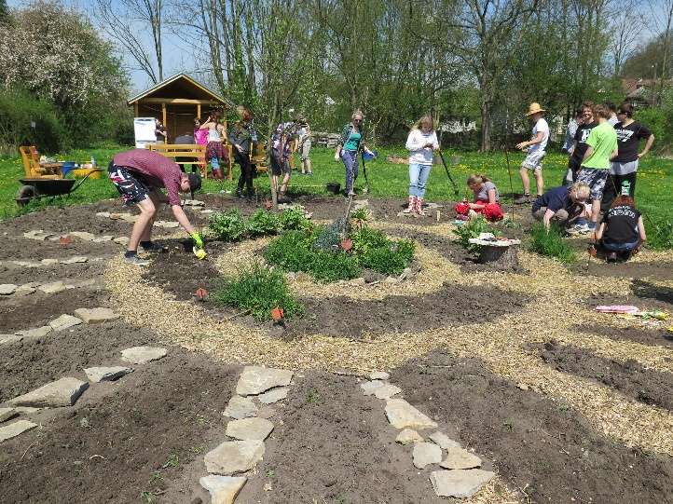
At the moment Sdružení SPLAV covers the basic expenses for the garden (seeds, petrol etc.) from their own resources. The maintenance is possible with the help of Employment office, which provides few full time workers.

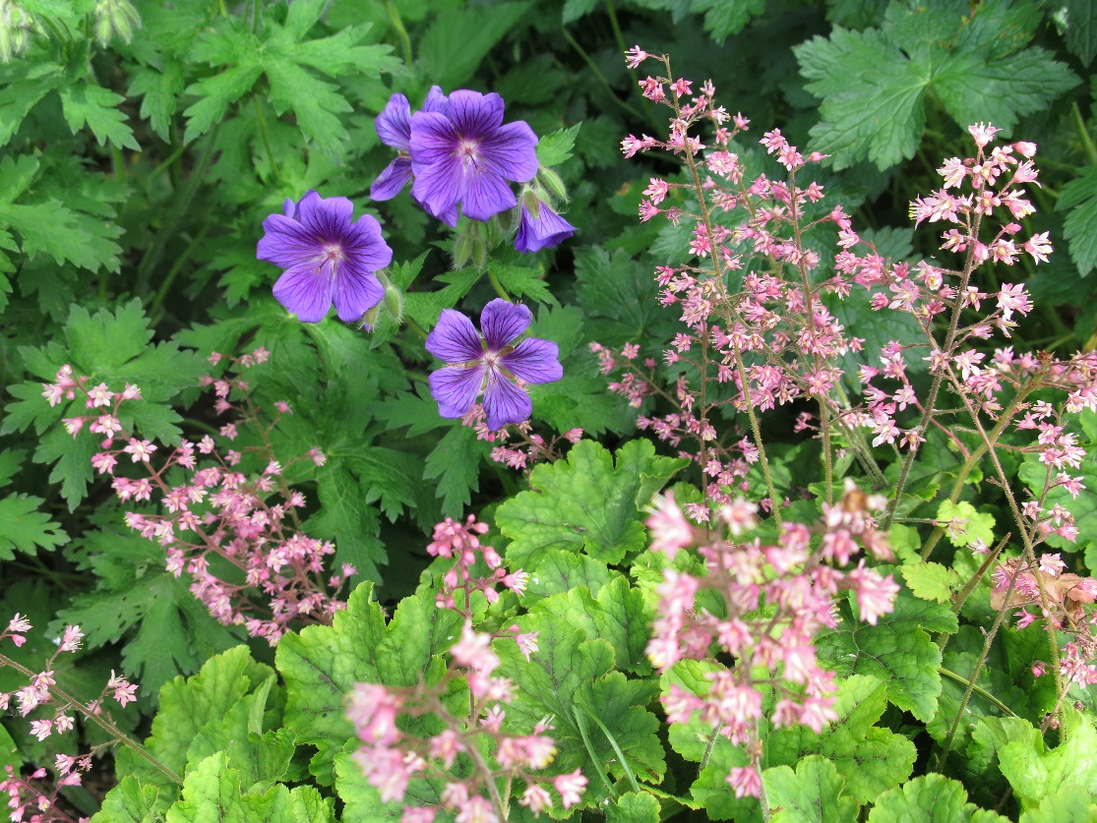

Continuously the garden is being developed into an open space where people are meeting in regular events, which are either just for them or opened for public. Wide range of people is benefiting from the community garden – local schools and kindergartens, people with special need or local residents.

In 2018 starts new project based on the community garden called ´Work together, together with SPLAV´ focused on helping people disadvantaged on labour market and on networking with all regional institutions and associations with similar portfolio.

Photography on cover page: By W.carter (Own work) [CC BY-SA 4.0 (https://creativecommons.org/licenses/by-sa/4.0)], via Wikimedia Commons
We are responsible for the quality of our environment – you are too! You can make a real difference for the world we live in. Start acting!

 | Polski Klub Ekologiczny  Koło Miejskie w Gliwicach  ul. Ziemowita 1,  44-10 Gliwice  Polska  biuro@pkegliwice.pl  www.pkegliwicepl |  | Sdruzeni SPLAV  Skuhrov nad Bělou 84  517 03 Skuhrov nad Bělou  Czech Republic  kristina@sdruzenisplav.cz  http://www.sdruzenisplav.cz/

Our mission is: Supporting sustainable development, saving and improving the environment, protection of nature and life, as well as human health.

This publication has been prepared and printed with support of International Visegrad Fund in frame of project „Cooperation for Sustainable Resources Management of Armenian Cities and City Areas“ No 21710379

Brochure developmnet: Maria Staniszewska, Karolina Chomacka, Kristina Garrido Holmova
Editor: Karolina Chomacka
Graphic design and typesetting: Magdalena Niglus
Printing house : Epigraf s.c. Gliwice
Printed on ecological paper

